Kapture - MGSS Batch Jobs (kAuthor) Unit Test Cases

Contents
1. Batch Job Configuration (kAuthor) 3
2. Carline Notification (CarlineNotification) 8
3. MDM Category Update (MDMCategoryUpdate) 12
4. MME VC ESI Labels Update (MMEVCESILabelsUpdate) 15
5. SI Inner Links Identification (SIInnerLinksIdentification) 19
6. MNAO View Content Model Year (MNAOViewContentModelYear) 23
7. MNAO View Content VIN (MNAOViewContentVIN) 26
8. MC View Content (MCViewContent) 29
9. MME View Content (MMEViewContent) 32

Kapture - MGSS Batch Jobs (kAuthor)
Unit Test Cases
Application: kAuthor - Configuration > Batch Jobs (kauthor-api) | Version: v1 | Date: 11-Nov-2026
- Unit Test Case Summary:
# | Test Cases Processes | No. of Test Cases | No. of Success | No. of Failure | Status
1 | Batch Job Configuration (kAuthor) | 4 | 4 | 0 | Pass
2 | Carline Notification (CarlineNotification) | 3 | 3 | 0 | Pass
3 | MDM Category Update (MDMCategoryUpdate) | 3 | 3 | 0 | Pass
4 | MME VC ESI Labels Update (MMEVCESILabelsUpdate) | 3 | 3 | 0 | Pass
5 | SI Inner Links Identification (SIInnerLinksIdentification) | 3 | 3 | 0 | Pass
6 | MNAO View Content Model Year (MNAOViewContentModelYear) | 3 | 3 | 0 | Pass
7 | MNAO View Content VIN (MNAOViewContentVIN) | 3 | 3 | 0 | Pass
8 | MC View Content (MCViewContent) | 3 | 3 | 0 | Pass
9 | MME View Content (MMEViewContent) | 3 | 3 | 0 | Pass
 | Total | 28 | 28 | 0 | Pass

Batch Job Configuration (kAuthor)
The MGSS custom batch jobs run inside Kapture (kauthor-api) and are managed from kAuthor > Configuration > Batch Jobs. The screen actions below were executed on CarlineNotification; they work the same way for every MGSS batch job. Executed on MC Dev (kAuthor version MC.2026.11.4.2) on 10 and 11-Nov-2026. Log times are UTC; the kAuthor screens show local time (IST, UTC + 5:30). Reports are written under the Kapture content library (.../GMS3_CUSTOM/...).
- User should be able to view the MGSS batch jobs in the Batch JOB List.
Steps:
1. Log in to kAuthor with an administrator user.
2. Search the menu for Batch and open Configuration > Batch Jobs.
Expected Result:
- All Active Jobs lists the MGSS batch jobs with status Active, Job Type MGSS Batch Job, the last executed date and the actions History, Run and Update.
- The 8 jobs covered in this document are listed: CarlineNotification, MCViewContent, MDMCategoryUpdate, MMEVCESILabelsUpdate, MMEViewContent, MNAOViewContentModelYear, MNAOViewContentVIN and SIInnerLinksIdentification.
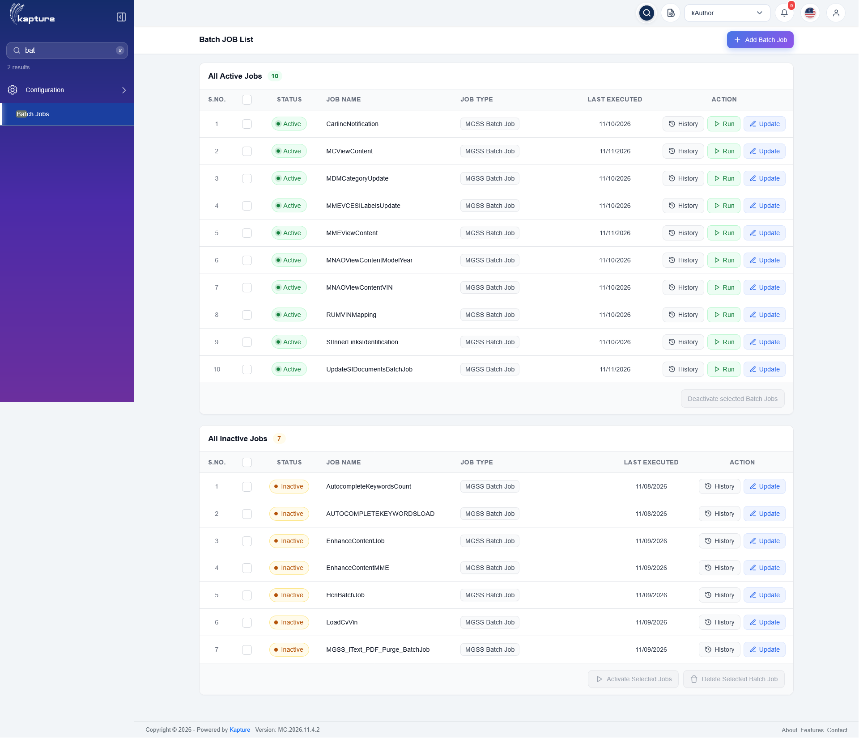
Batch JOB List
Status: Pass
Remarks:

- User should be able to view the execution history of a batch job.
Steps:
1. Click History on CarlineNotification.
Expected Result: Batch Job History lists each execution with its id, Last Executed date / time and the number of affected subscriptions.
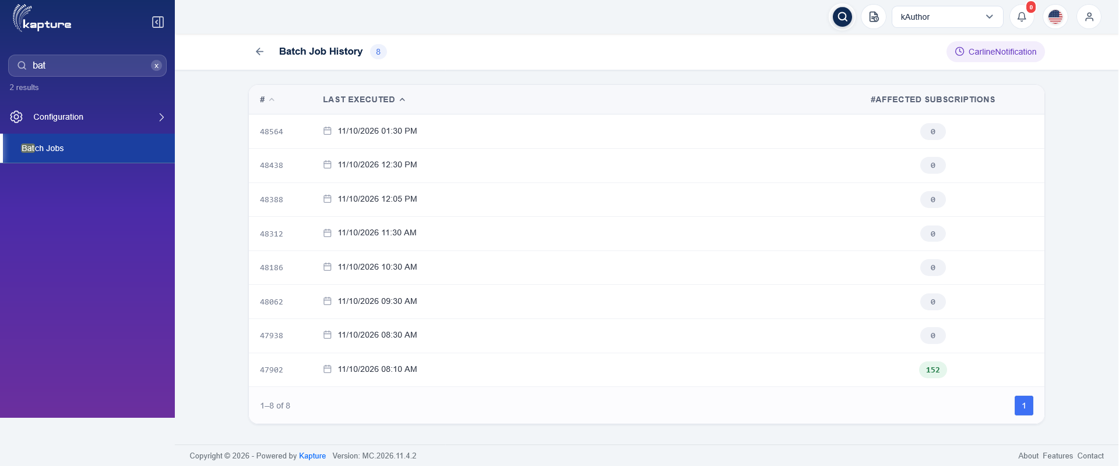
CarlineNotification - Batch Job History
Status: Pass
Remarks:

- User should be able to update the schedule of a batch job.
Steps:
1. Click Update on CarlineNotification.
2. Select the schedule (Recurring Every n hours / days) and the Retention Period.
3. Click Update batch job.
Expected Result:
- "Subscription Job updated successfully" is shown.
- The job is re-scheduled at once with the new schedule, without a restart: the log shows "Scheduling Carline Notification custom batch job ... jobFreq=RECURRING_HOURS" and "scheduled at cron '0 0 */1 ? * * *'".
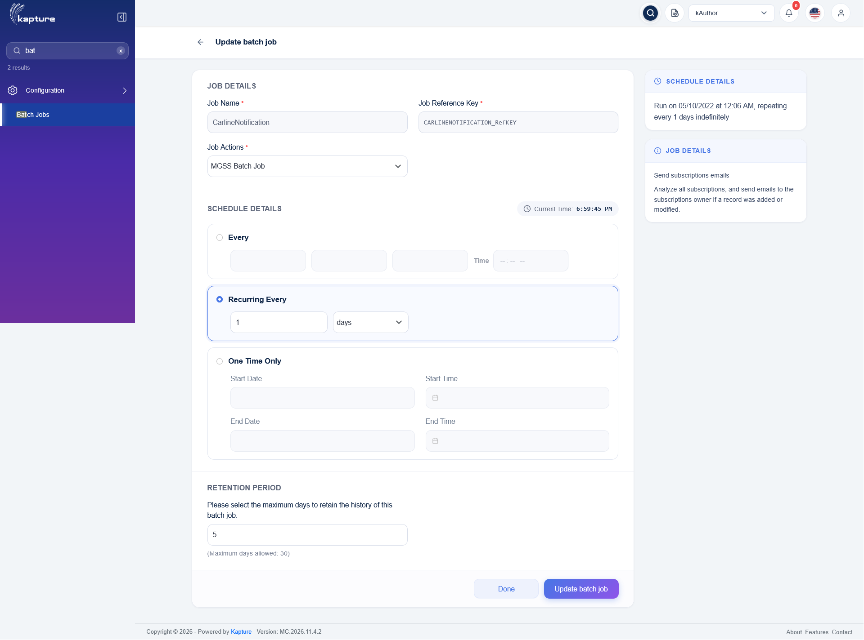
Update batch job
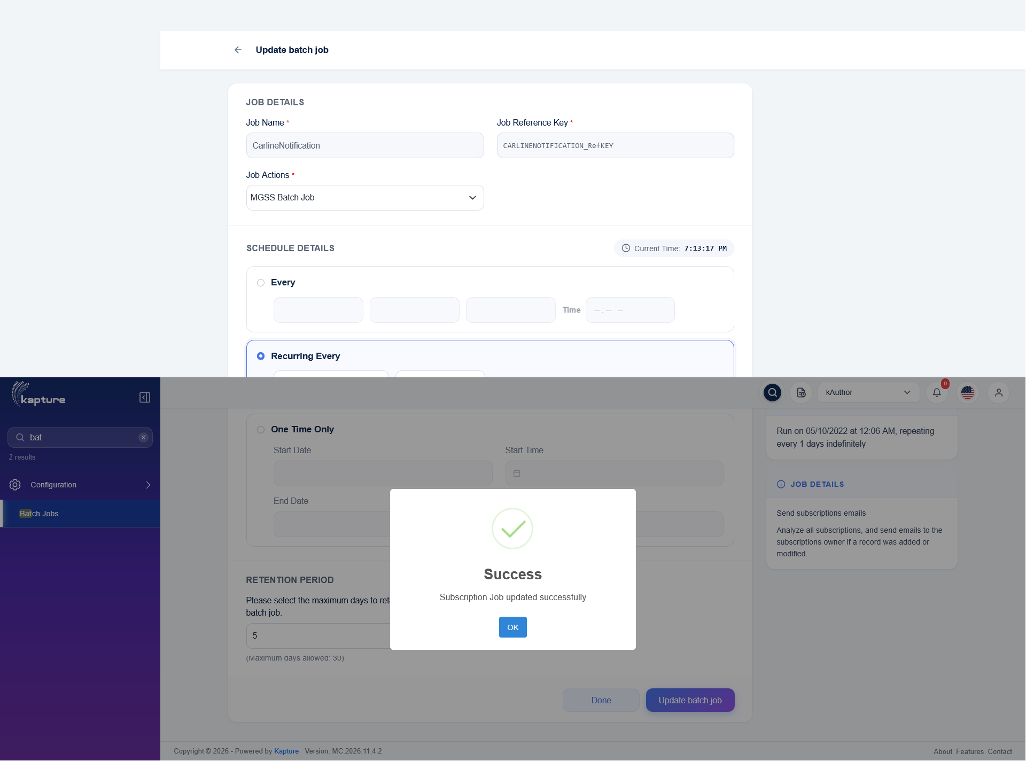
Update saved
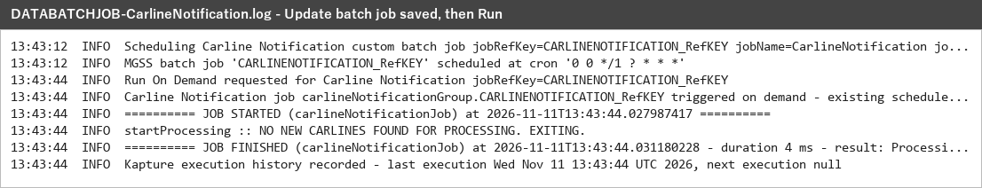
DATABATCHJOB-CarlineNotification.log
Status: Pass
Remarks:

- User should be able to run a batch job on demand.
Steps:
1. Click Run on CarlineNotification.
2. Open History of the job.
Expected Result:
- The job runs immediately: the log shows "Run On Demand requested", "triggered on demand - existing schedule kept", JOB STARTED and JOB FINISHED.
- The execution is recorded and listed first in Batch Job History (11/11/2026 07:15 PM).
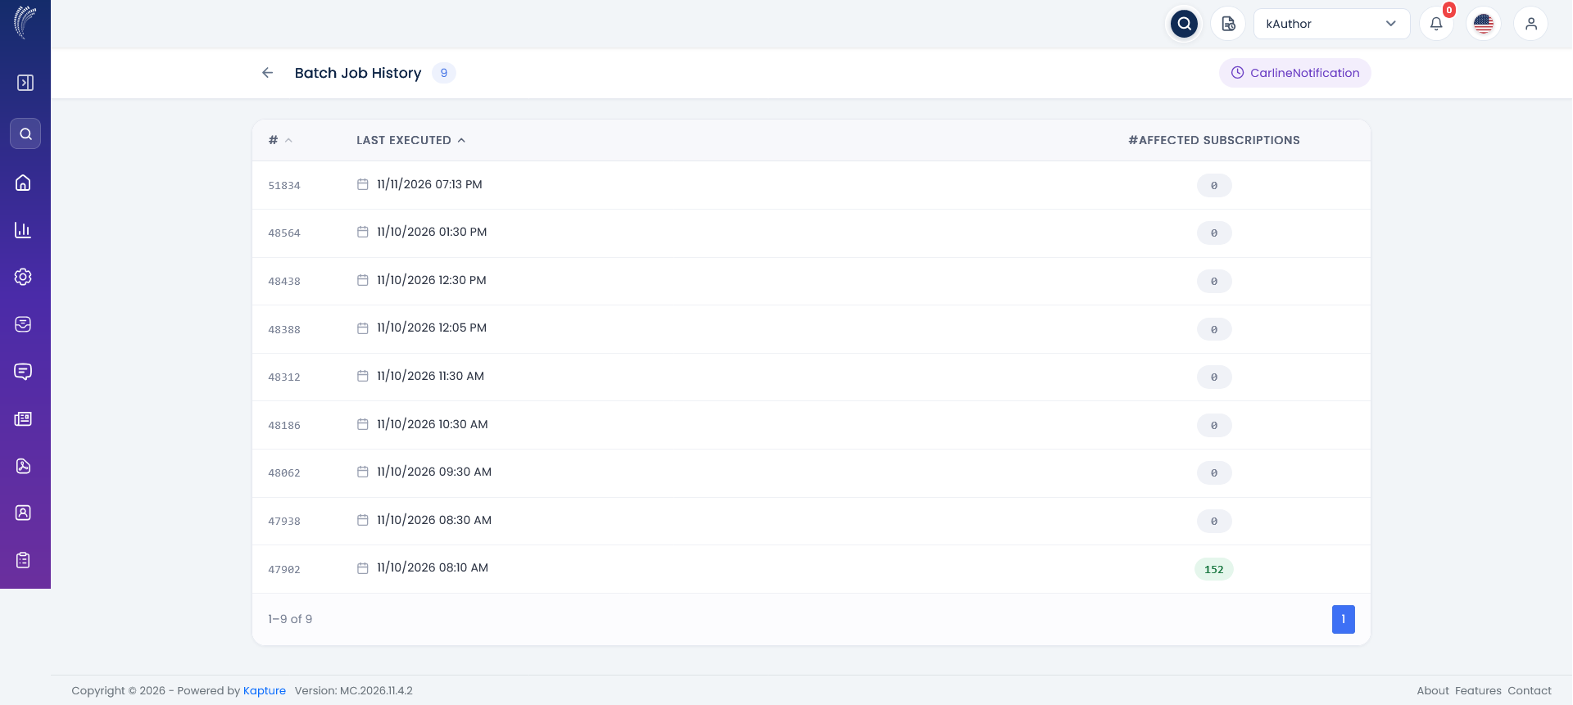
Batch Job History after Run
DATABATCHJOB-CarlineNotification.log
Status: Pass
Remarks: No new carline was pending at that time, so the run ended with "NO NEW CARLINES FOUND FOR PROCESSING" (expected).

Carline Notification (CarlineNotification)
Mails the owners of the published SI documents mapped to ALL_CARLINE when new carlines are added in MDM (gms3_mdm_carline_codes), one report and mail per locale, then flags the carlines as notified.
- User should be able to view the schedule of the CarlineNotification batch job.
Steps:
1. Open kAuthor and go to Configuration > Batch Jobs.
2. Click Update on CarlineNotification.
Expected Result:
- Update batch job shows Job Name CarlineNotification, its Job Reference Key and Job Actions MGSS Batch Job.
- Schedule Details: Recurring Every 1 days; Retention Period 5 days.
CarlineNotification - Update batch job
Status: Pass
Remarks:

- System should notify the new carlines of each locale and flag them as notified.
Pre-condition: New carlines added in MDM for fr-CA, en-UK, en-US, ja-JP and es-MX.
Steps:
1. Run CarlineNotification.
2. Check DATABATCHJOB-CarlineNotification.log and History.
Expected Result:
- 5 locales with new carlines are found (fr-CA 109, en-UK 21, en-US 12, ja-JP 7, es-MX 3).
- Per locale: owners identified, report written, mail sent to the owners (subject "New Carline's Introduced for MNAO / MME / MC.") and the carline rows flagged (152 in total).
- The execution is listed in Batch Job History.
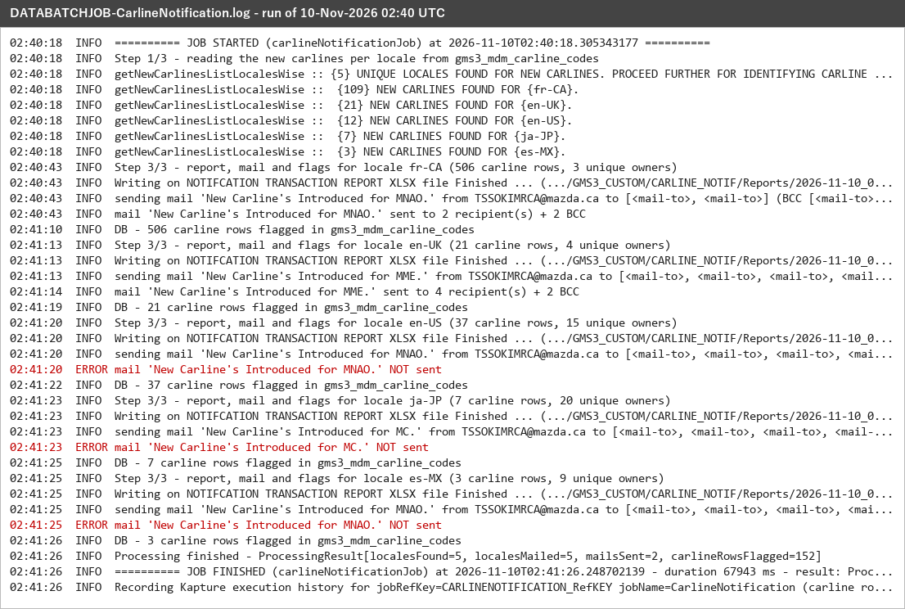
DATABATCHJOB-CarlineNotification.log - 10-Nov-2026 02:40 UTC
CarlineNotification - Batch Job History
Status: Pass
Remarks: Mails for fr-CA and en-UK were sent. The en-US, ja-JP and es-MX mails were not sent because some owner e-mail addresses in the Kapture user data are invalid (e.g. "...@mazda.co.jp@mazda.co.jp"): user data issue, not a job issue.

- System should write one carline details report per locale.
Steps:
1. Open GMS3_CUSTOM/CARLINE_NOTIF/Reports/<run time>.
Expected Result: <LOCALE>_CARLINE_DETAILS.xlsx for each locale, with LOCALE, WMI CODE, CARLINE CODE, CARLINE NAME and YEAR of the new carlines.
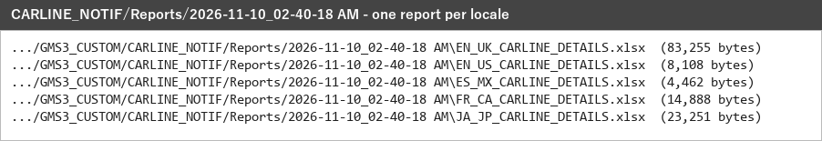
Reports folder
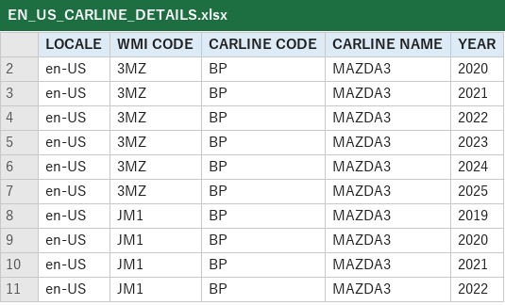
EN_US_CARLINE_DETAILS.xlsx
Status: Pass
Remarks:

MDM Category Update (MDMCategoryUpdate)
Creates / updates the MNAO VIN categories in Kapture (VIN > WMI > VDS > VIS levels from gms3_mdm_sivin_add) for the locales en_US, en_CA, es_MX and fr_CA.
- User should be able to view the schedule of the MDMCategoryUpdate batch job.
Steps:
1. Open kAuthor and go to Configuration > Batch Jobs.
2. Click Update on MDMCategoryUpdate.
Expected Result:
- Update batch job shows Job Name MDMCategoryUpdate, its Job Reference Key and Job Actions MGSS Batch Job.
- Schedule Details: Recurring Every 1 days; Retention Period 5 days.
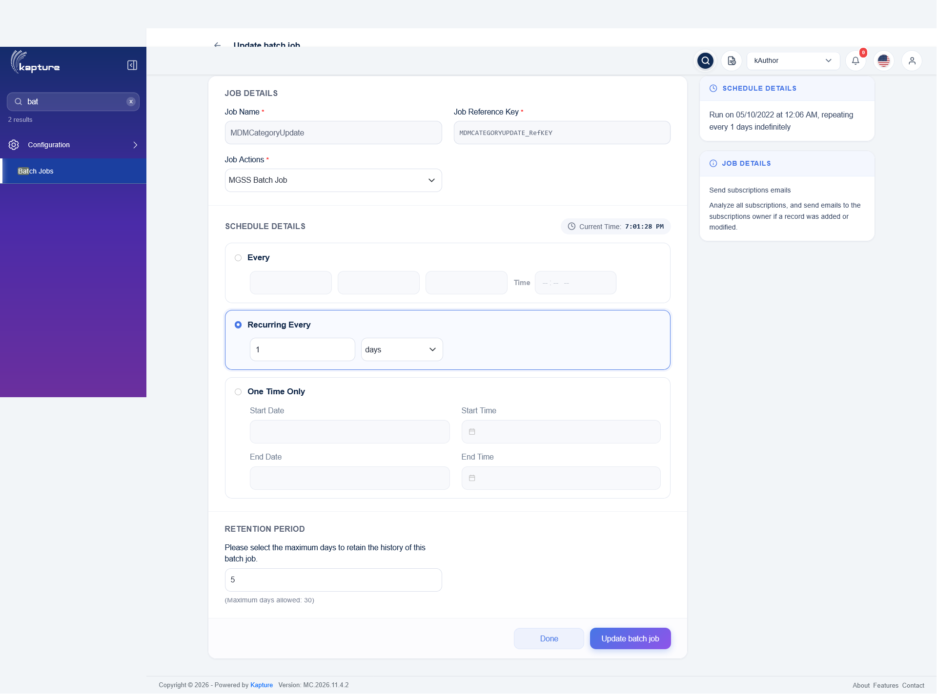
MDMCategoryUpdate - Update batch job
Status: Pass
Remarks:

- System should create / update the VIN categories in Kapture and refresh the category caches.
Steps:
1. Run MDMCategoryUpdate.
2. Check DATABATCHJOB-MDMCategoryUpdate.log and History.
Expected Result:
- First run (no last processed time) reads all levels: 8 first, 31 second and 39 third level categories (78), each created / updated for the 4 locales.
- Reports zipped, mail "MDM Category Data Load - <time>" sent, last processed time written and the Kapture category caches refreshed.
- History shows the execution with 78 affected items.
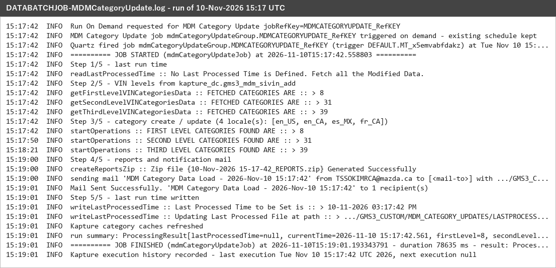
DATABATCHJOB-MDMCategoryUpdate.log - 10-Nov-2026 15:17 UTC
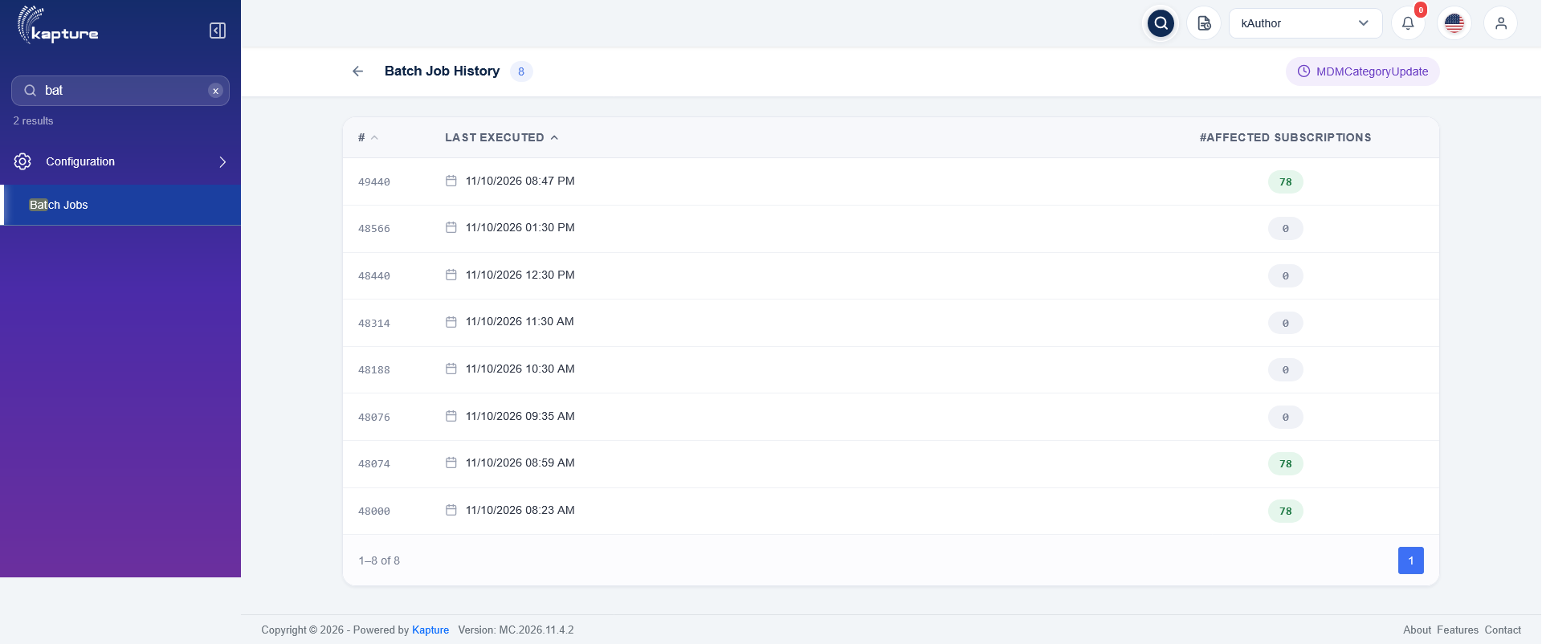
MDMCategoryUpdate - Batch Job History
Status: Pass
Remarks:

- System should write the transaction report and the last processed time.
Steps:
1. Open GMS3_CUSTOM/MDM_CATEGORY_UPDATES.
Expected Result:
- <run time>/<run time>_REPORTS.zip holds TRANSACTION_REPORT.xlsx: processing level, category ref key, name, parent ref key, locale, status and remark of each category (all SUCCESS).
- LASTPROCESSEDTIMESTAMP.txt = 10-11-2026 03:17:42 PM (start of the run); the next run reads only the VIN data changed after it.
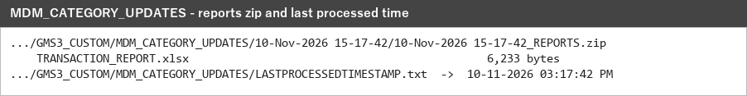
MDM_CATEGORY_UPDATES folder
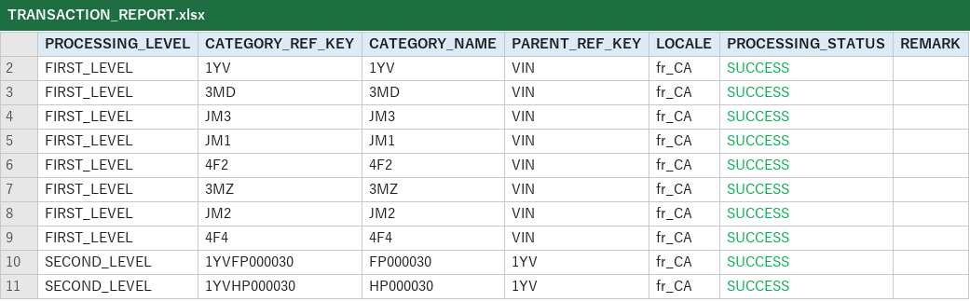
TRANSACTION_REPORT.xlsx
Status: Pass
Remarks:

MME VC ESI Labels Update (MMEVCESILabelsUpdate)
Stamps the ESI category names (MDM, in the ESI name language of the locale) on the MME View Content rows flagged N, and records the run as an ESI Labels Update schedule visible in MDM.
- User should be able to view the schedule of the MMEVCESILabelsUpdate batch job.
Steps:
1. Open kAuthor and go to Configuration > Batch Jobs.
2. Click Update on MMEVCESILabelsUpdate.
Expected Result:
- Update batch job shows Job Name MMEVCESILabelsUpdate, its Job Reference Key and Job Actions MGSS Batch Job.
- Schedule Details: Recurring Every 1 days; Retention Period 5 days.
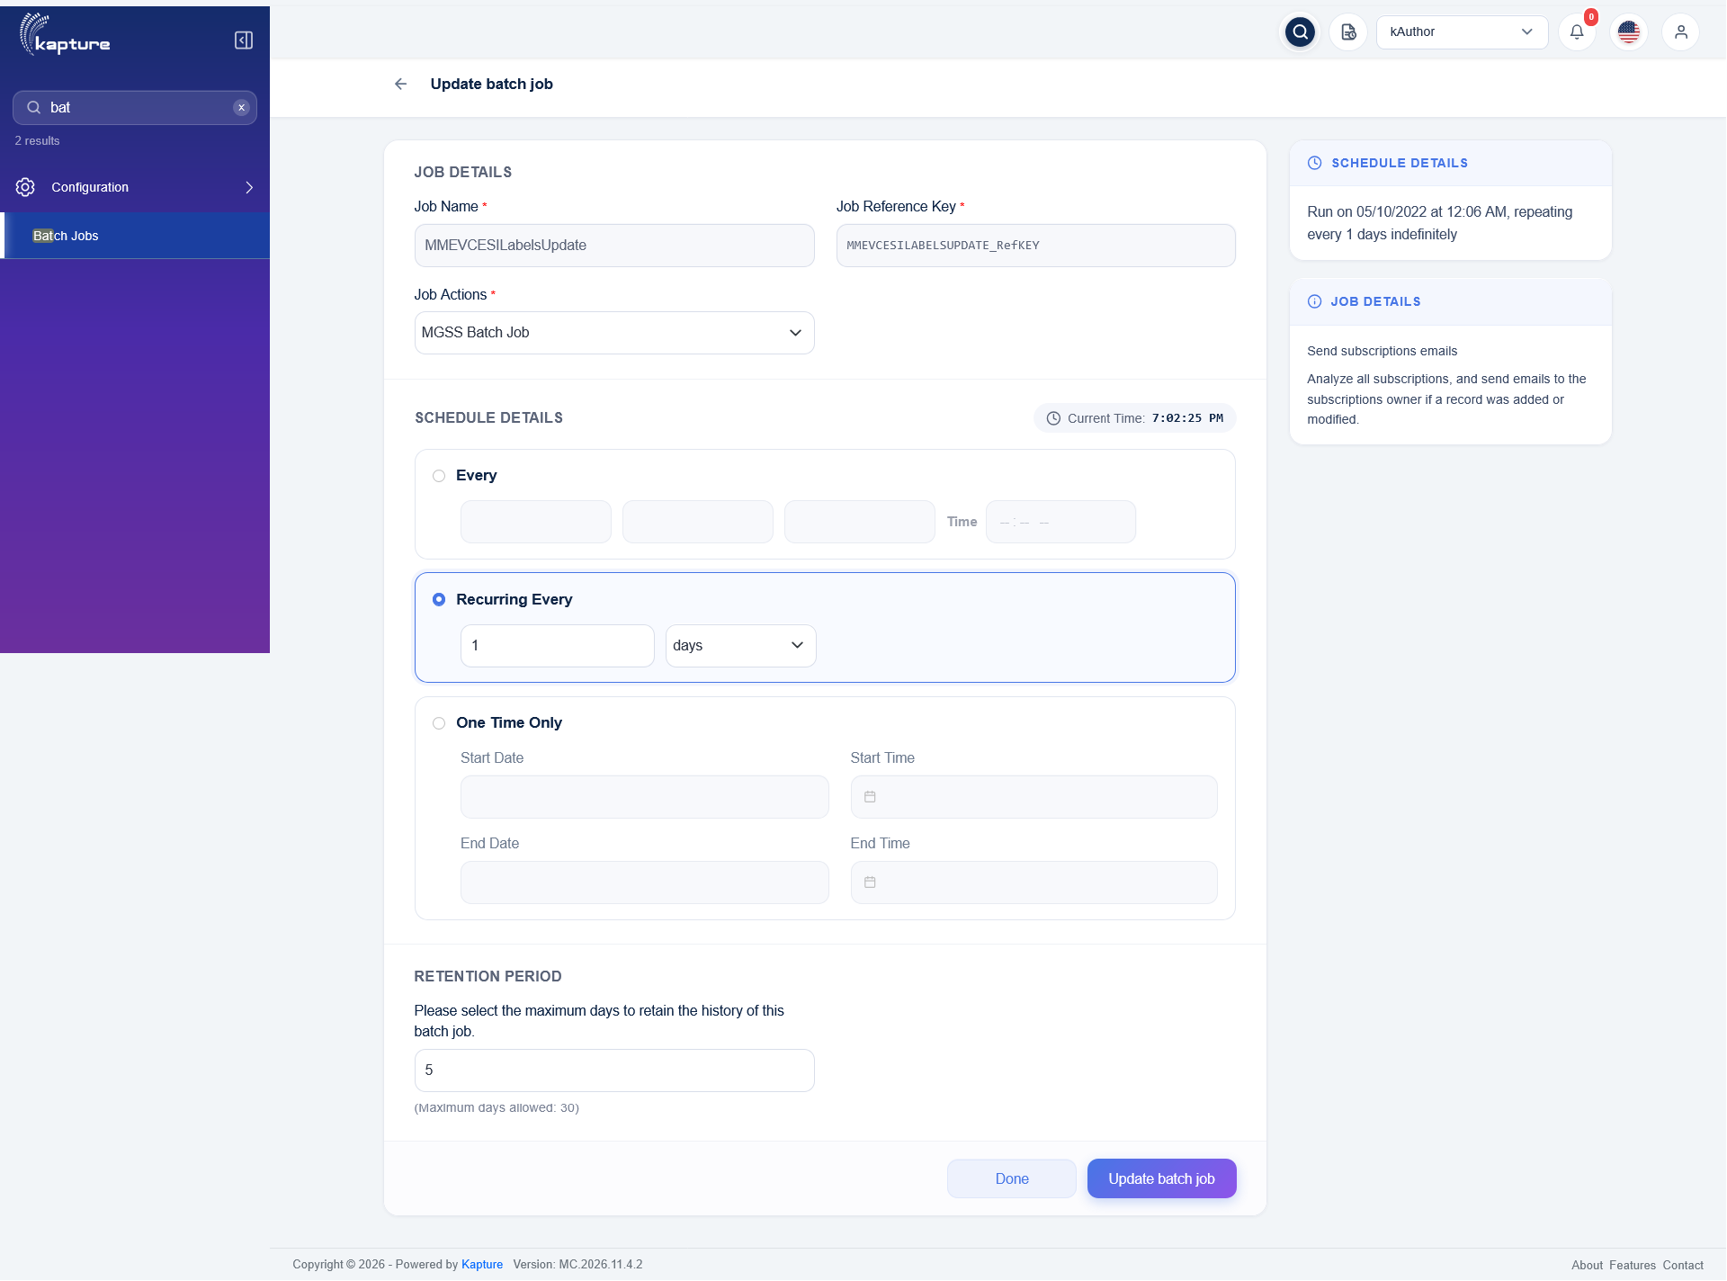
MMEVCESILabelsUpdate - Update batch job
Status: Pass
Remarks:

- System should update the ESI category labels of the MME View Content rows flagged N.
Steps:
1. Run MMEVCESILabelsUpdate.
2. Check DATABATCHJOB-MMEVCESILabelsUpdate.log and History.
Expected Result:
- Schedule GMS3_MME_ESIUP_SCH_12382 is created; 20,814 rows flagged N are read (View Content table + the per-locale MME tables).
- Labels identified and updated: 20,813 success, 1 failure; reports zipped and the schedule row completed.
- History shows the execution with 20,813 affected rows.
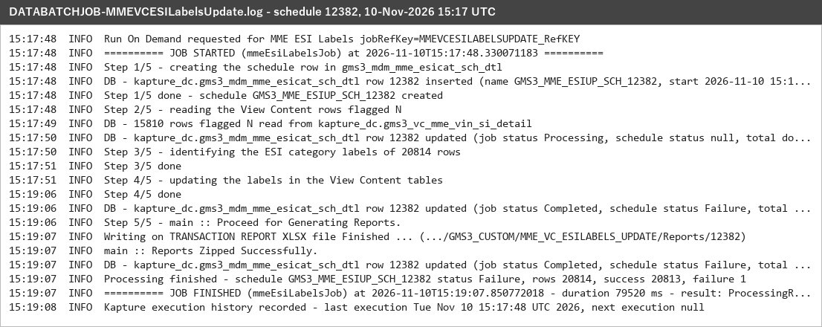
DATABATCHJOB-MMEVCESILabelsUpdate.log - schedule 12382
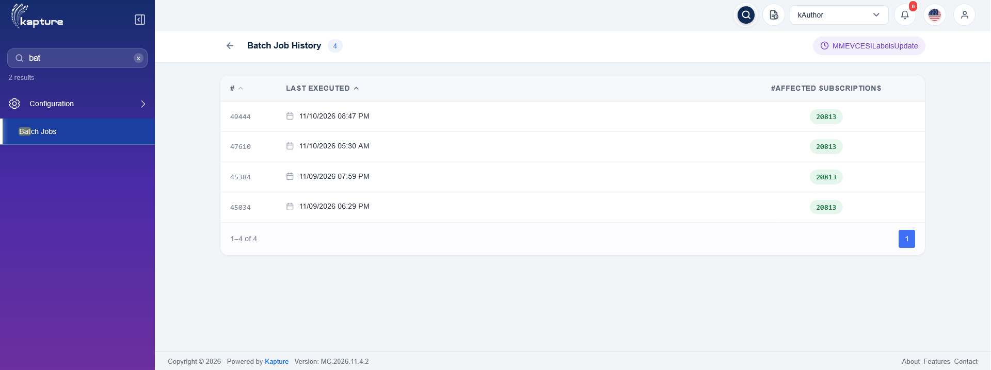
MMEVCESILabelsUpdate - Batch Job History
Status: Pass
Remarks: The 1 failure is a ru_RU row with no document id in the View Content table (data issue).

- User should be able to view the run in MDM > ESI Labels Update Schedule and its report.
Steps:
1. Open MDM > Tools, Import and Export > ESI Labels Update Schedule.
2. Download the report of GMS3_MME_ESIUP_SCH_12382.
Expected Result:
- Execution History lists GMS3_MME_ESIUP_SCH_12382 with documents 20814 / 20813 / 1, job status Completed and its report.
- 12382_TRANSACTION_REPORT.xlsx lists each document with the existing and the new category names, the ESI flag and the processing status.
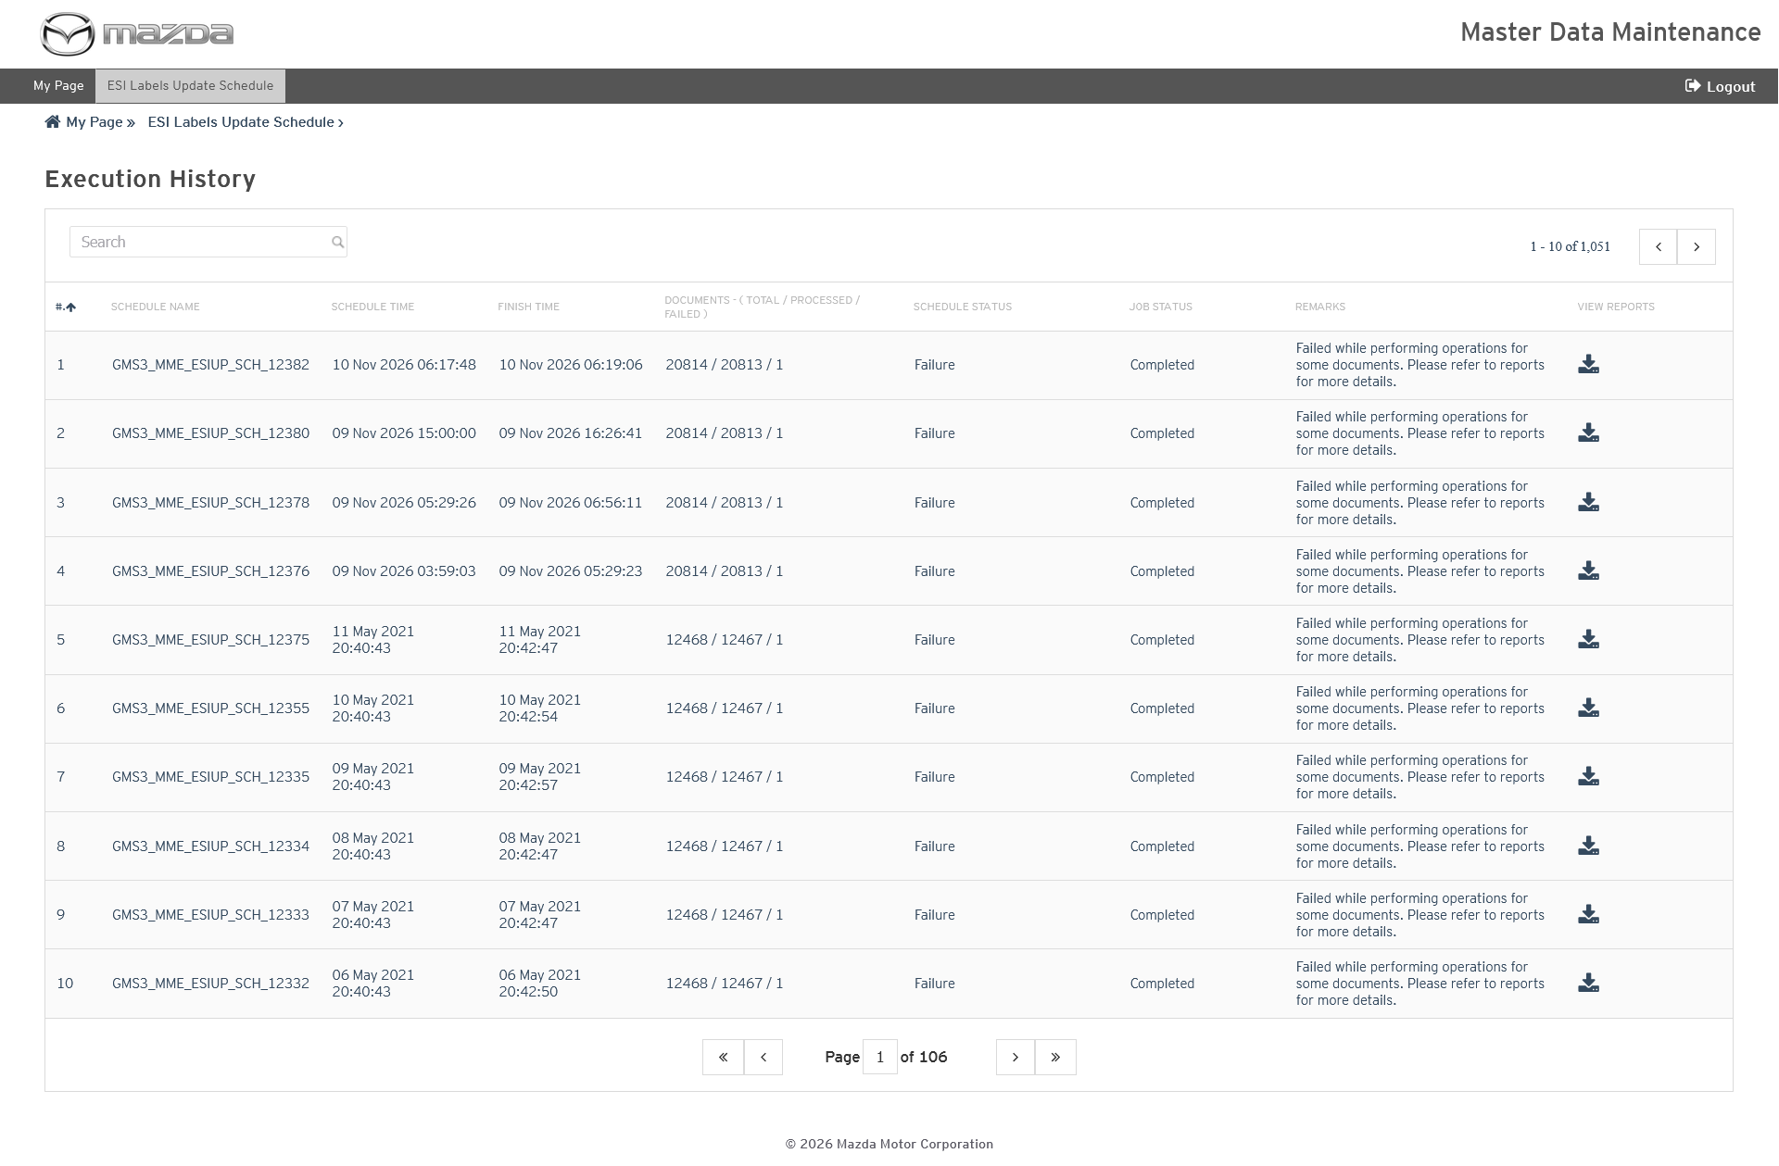
MDM - ESI Labels Update Schedule
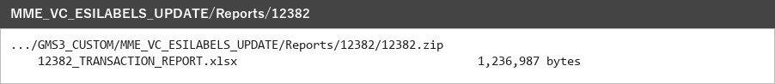
Reports folder
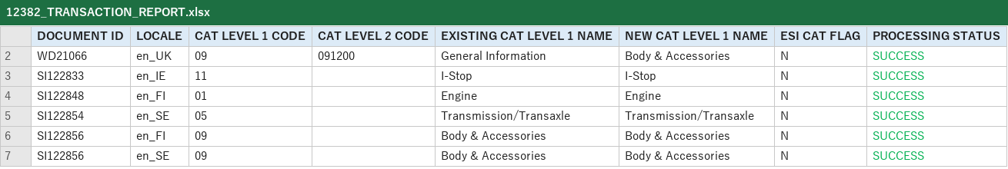
12382_TRANSACTION_REPORT.xlsx
Status: Pass
Remarks:

SI Inner Links Identification (SIInnerLinksIdentification)
Checks the Service Manual inner links of every SI document in the 36 SI locales and reports the active / inactive links per locale; the run is visible in MDM > SI InnerLinks Validation Reports.
- User should be able to view the schedule of the SIInnerLinksIdentification batch job.
Steps:
1. Open kAuthor and go to Configuration > Batch Jobs.
2. Click Update on SIInnerLinksIdentification.
Expected Result:
- Update batch job shows Job Name SIInnerLinksIdentification, its Job Reference Key and Job Actions MGSS Batch Job.
- Schedule Details: Recurring Every 1 days; Retention Period 5 days.
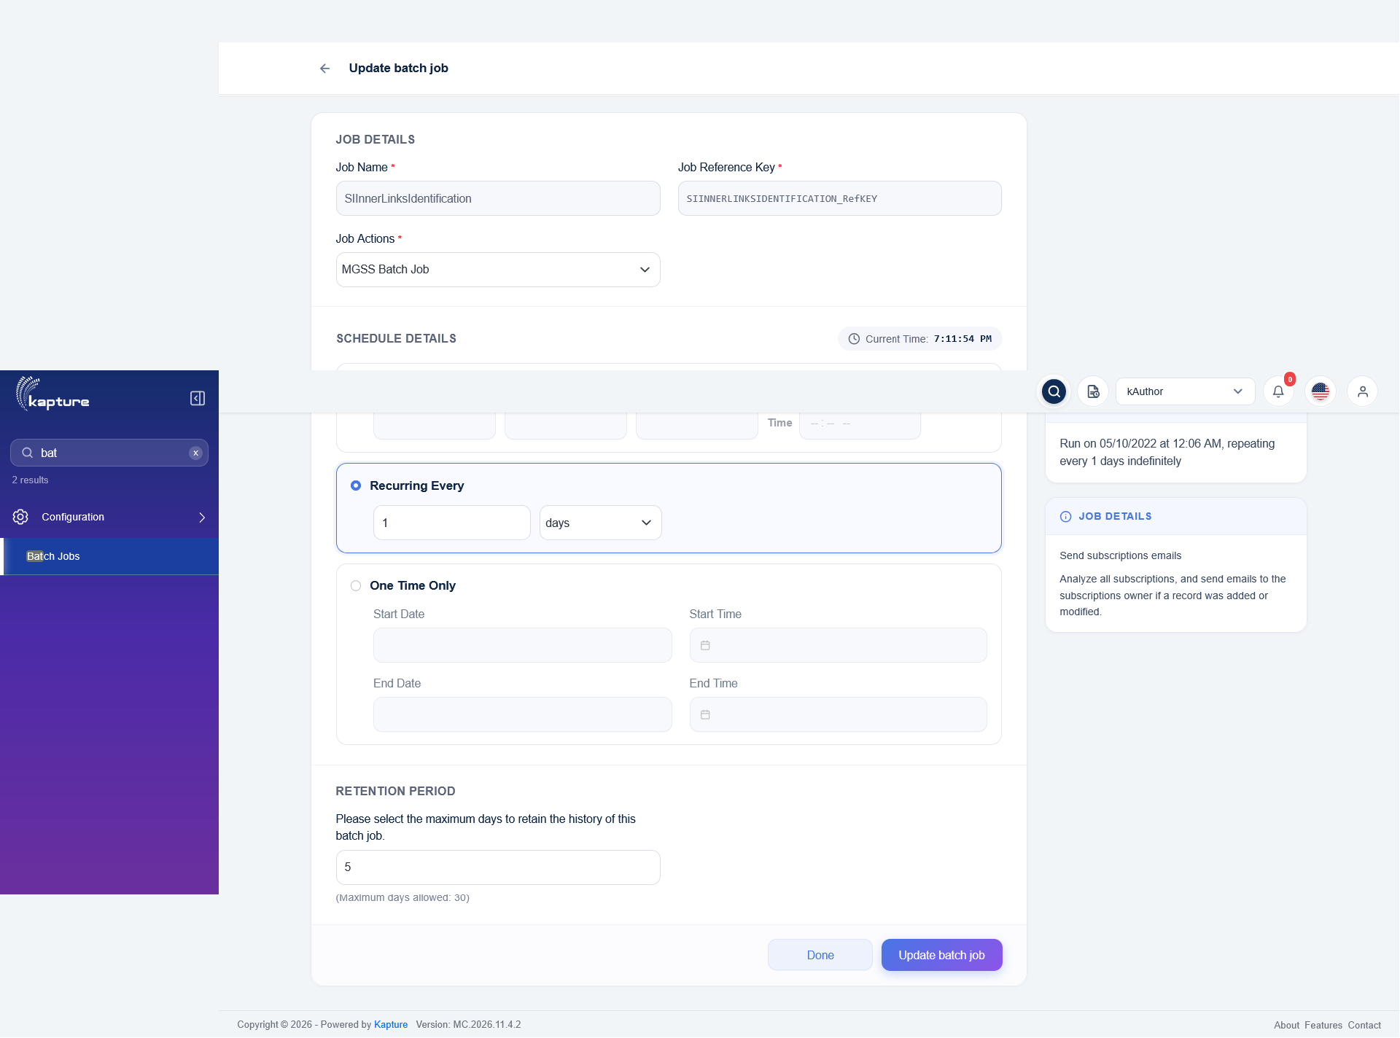
SIInnerLinksIdentification - Update batch job
Status: Pass
Remarks:

- System should identify the inner links of all SI documents and mail the reports.
Steps:
1. Run SIInnerLinksIdentification.
2. Check DATABATCHJOB-SIInnerLinksIdentification.log and History.
Expected Result:
- Schedule 884 created; 70,686 SI documents of 36 locales processed.
- Inner link rows written to one INNER_LINKS_REPORT.xlsx per locale, zipped per locale and mailed ("<locale> SI InnerLinks Validation Report - <time> - <status>").
- History shows the execution.
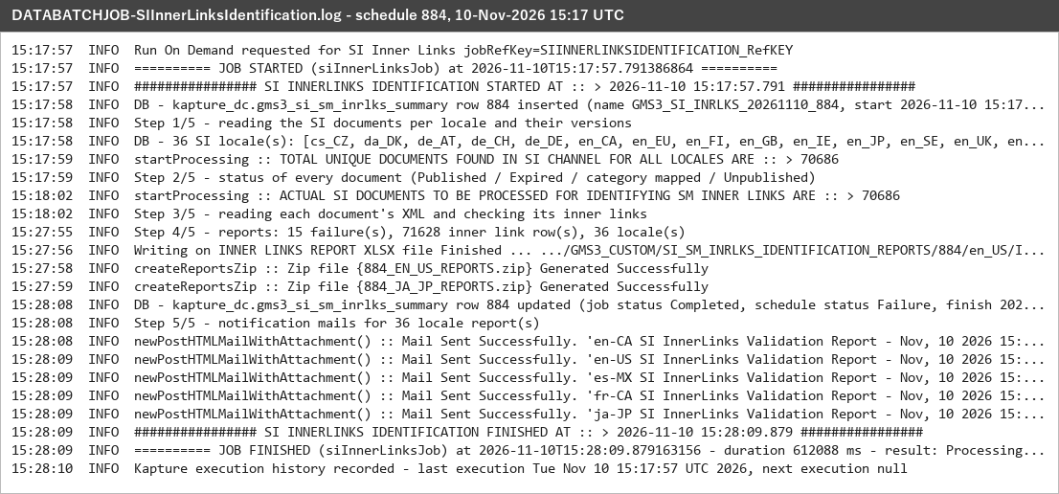
DATABATCHJOB-SIInnerLinksIdentification.log - schedule 884
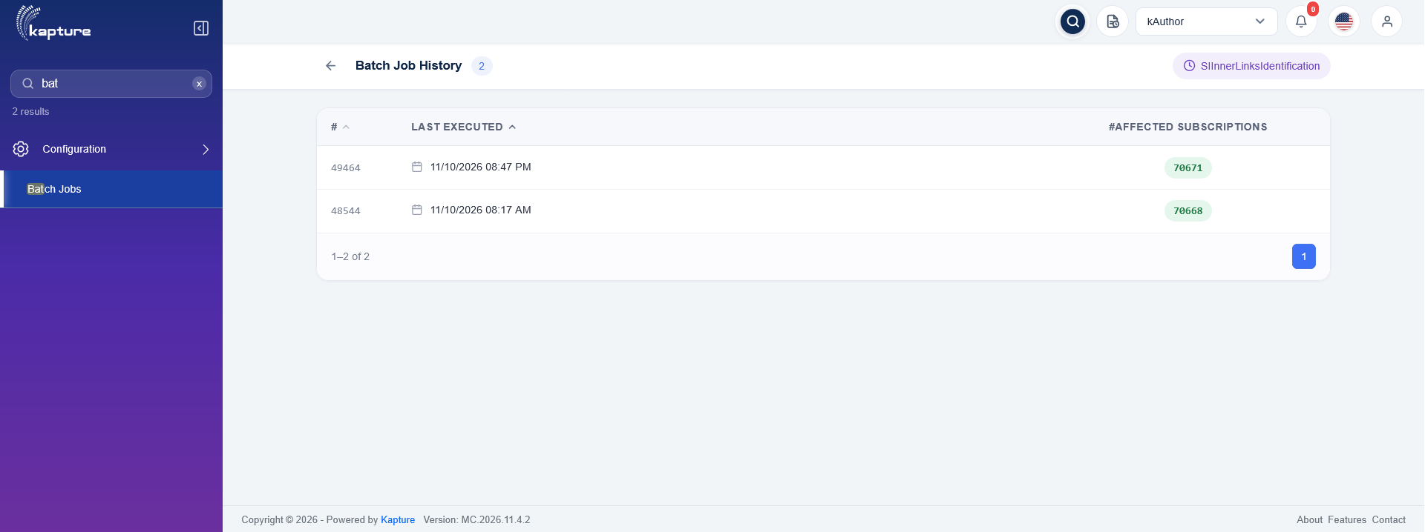
SIInnerLinksIdentification - Batch Job History
Status: Pass
Remarks: Schedule status Failure = 15 documents whose XML could not be read (content issue, same documents in every run); all other documents processed.

- User should be able to view the run in MDM > SI InnerLinks Validation Reports and its reports.
Steps:
1. Open MDM > SI InnerLinks Validation Reports.
2. Open the reports of schedule 884.
Expected Result:
- Execution History lists GMS3_SI_INRLKS_20261110_884: documents 70686 / 70671 / 15, inner links 1515 / 985 / 530, job status Completed.
- 884/<locale>/884_<LOCALE>_REPORTS.zip holds INNER_LINKS_REPORT.xlsx: SI document, inner link document, locale, status and inner link status.
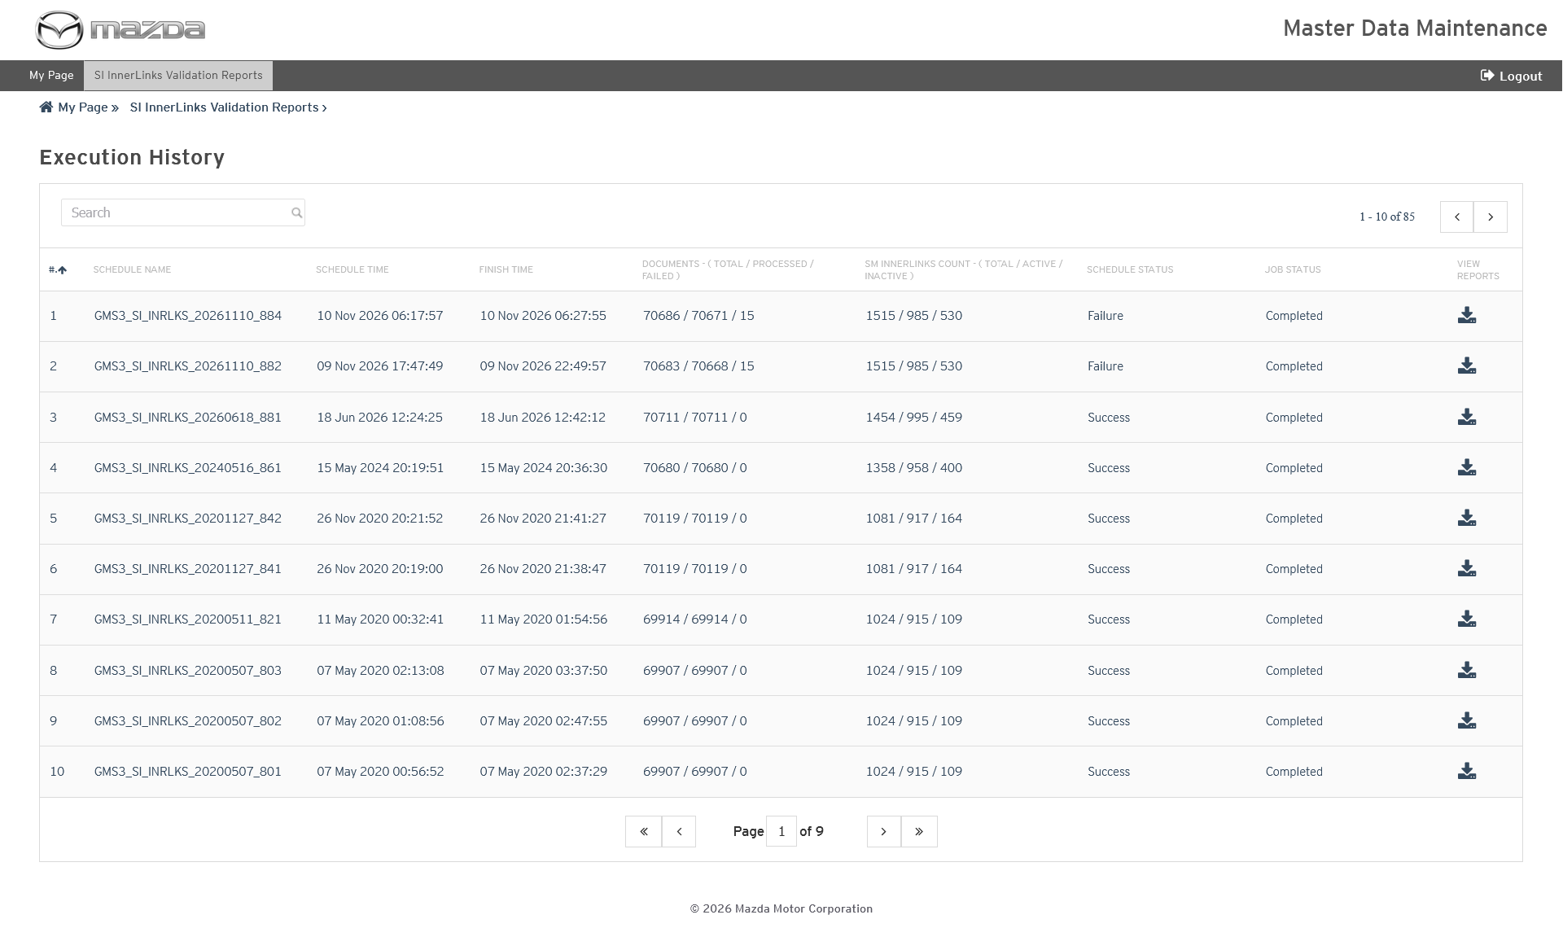
MDM - SI InnerLinks Validation Reports
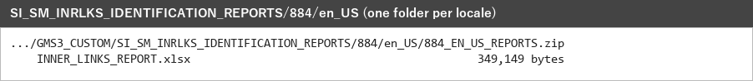
en_US reports
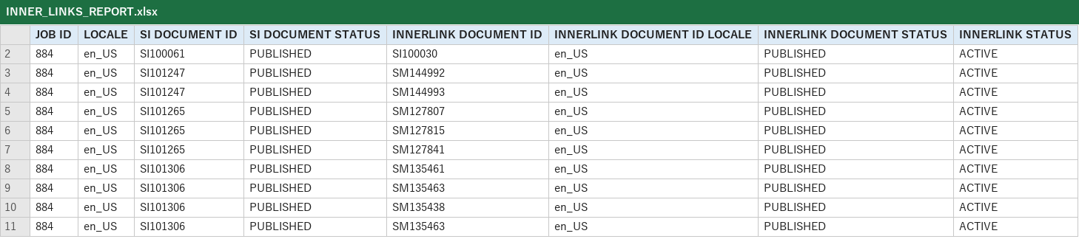
INNER_LINKS_REPORT.xlsx (en_US)
Status: Pass
Remarks:

MNAO View Content Model Year (MNAOViewContentModelYear)
Keeps the MNAO model year View Content table (gms3_vc_model_year_details) up to date for the SI and Accessories documents changed since the last run.
- User should be able to view the schedule of the MNAOViewContentModelYear batch job.
Steps:
1. Open kAuthor and go to Configuration > Batch Jobs.
2. Click Update on MNAOViewContentModelYear.
Expected Result:
- Update batch job shows Job Name MNAOViewContentModelYear, its Job Reference Key and Job Actions MGSS Batch Job.
- Schedule Details: Recurring Every 1 hours; Retention Period 5 days.
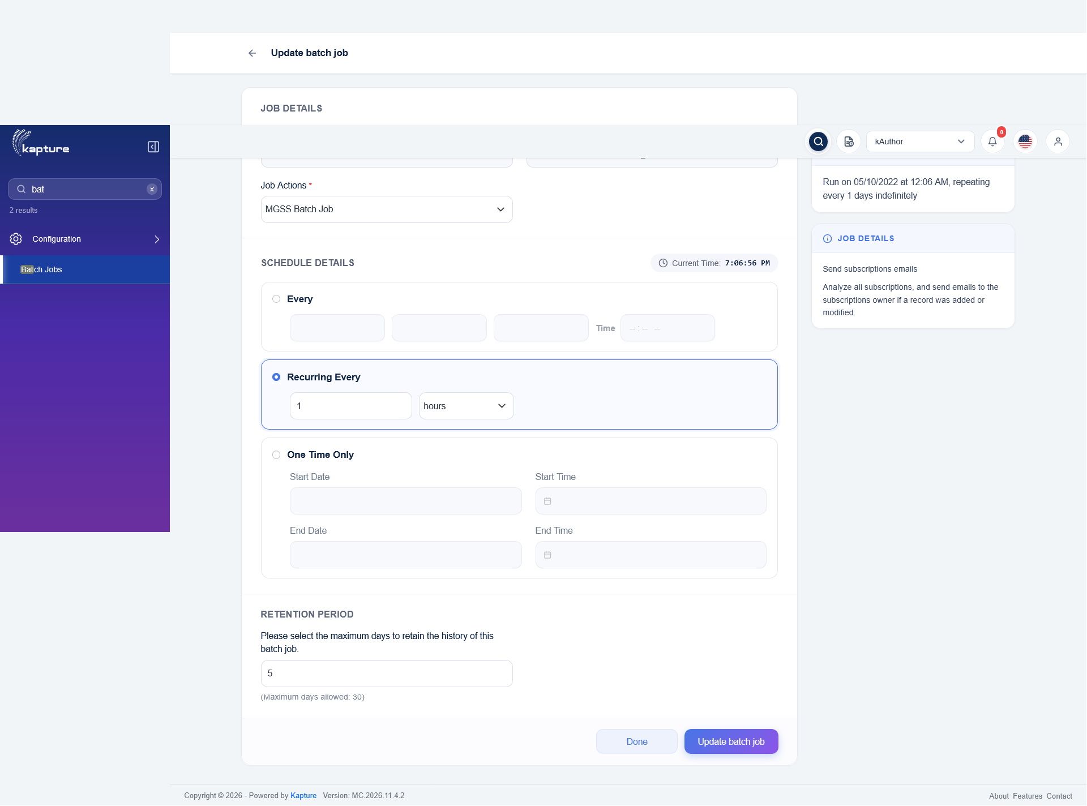
MNAOViewContentModelYear - Update batch job
Status: Pass
Remarks:

- System should rebuild the model year View Content rows of the changed documents.
Steps:
1. Run MNAOViewContentModelYear.
2. Check DATABATCHJOB-MNAOViewContentModelYear.log and History.
Expected Result:
- Documents changed since the last processed time are read (13,239 document + locale pairs).
- 62,437 View Content rows prepared; each document's rows are replaced in one transaction, 0 failed.
- Report zipped, mail "VIEW CONTENT SI UPDATE - <time>" sent and the last processed time written.
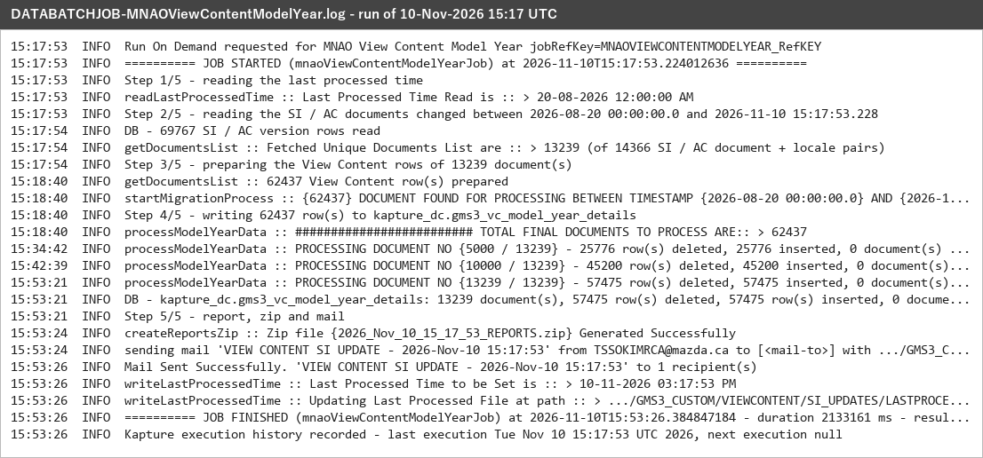
DATABATCHJOB-MNAOViewContentModelYear.log - 10-Nov-2026 15:17 UTC
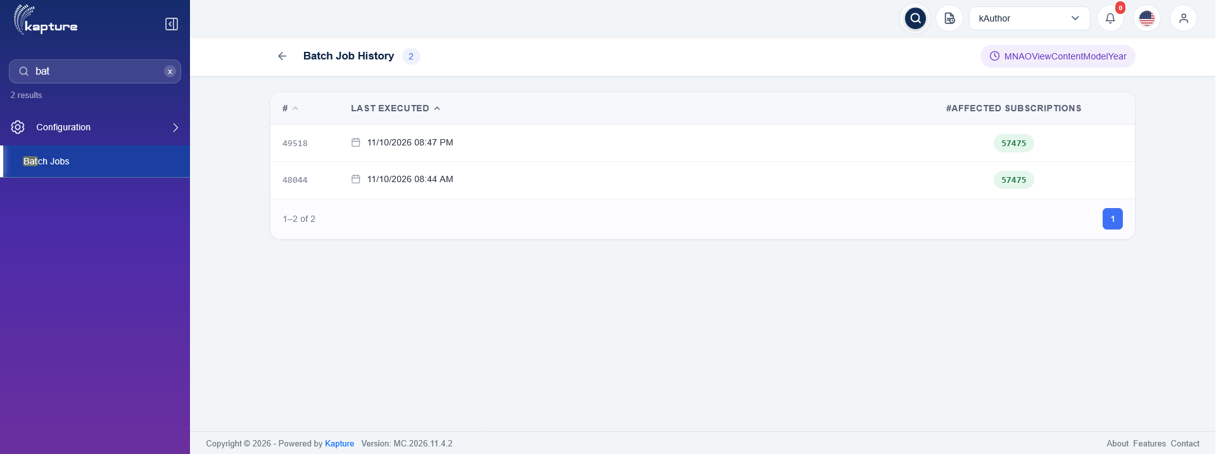
MNAOViewContentModelYear - Batch Job History
Status: Pass
Remarks:

- System should write the incremental data report and the last processed time.
Steps:
1. Open GMS3_CUSTOM/VIEWCONTENT/SI_UPDATES.
Expected Result:
- <run time>/<run time>_REPORTS.zip holds INCREMENTAL_DATA_REPORT.xlsx with locale, document, status, model, year, document type, ESI categories and document status of each row.
- LASTPROCESSEDTIMESTAMP.txt = 10-11-2026 03:17:53 PM.
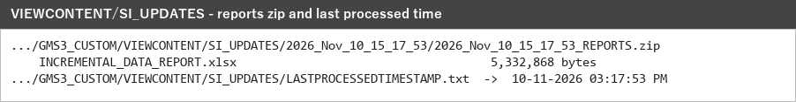
SI_UPDATES folder
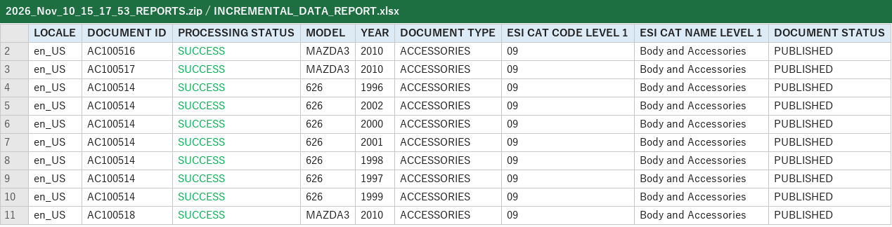
INCREMENTAL_DATA_REPORT.xlsx
Status: Pass
Remarks:

MNAO View Content VIN (MNAOViewContentVIN)
Keeps the MNAO VIN View Content table (gms3_vc_vin_details) up to date for the SI and Accessories documents changed since the last run.
- User should be able to view the schedule of the MNAOViewContentVIN batch job.
Steps:
1. Open kAuthor and go to Configuration > Batch Jobs.
2. Click Update on MNAOViewContentVIN.
Expected Result:
- Update batch job shows Job Name MNAOViewContentVIN, its Job Reference Key and Job Actions MGSS Batch Job.
- Schedule Details: Recurring Every 1 hours; Retention Period 5 days.
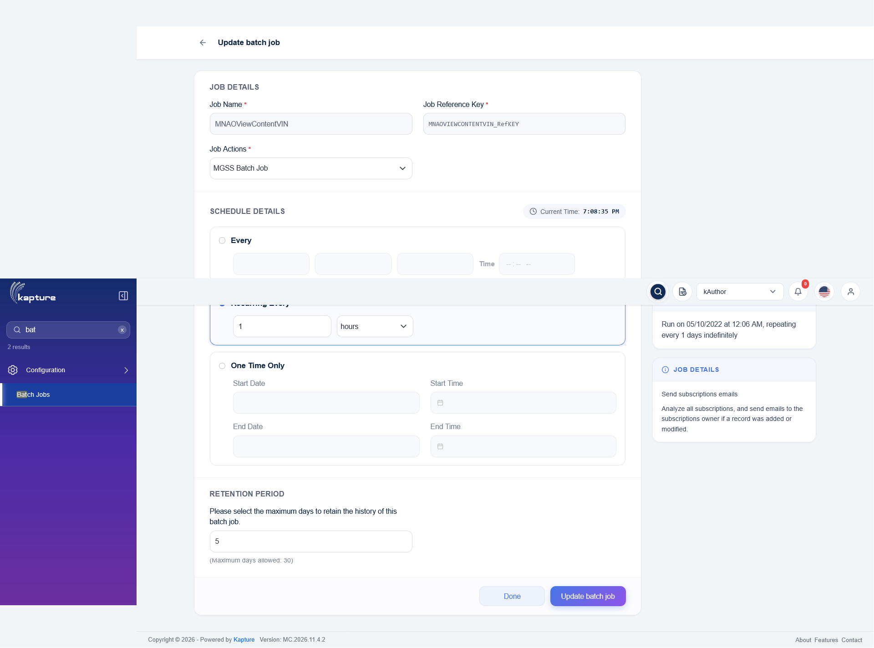
MNAOViewContentVIN - Update batch job
Status: Pass
Remarks:

- System should rebuild the VIN View Content rows of the changed documents.
Steps:
1. Run MNAOViewContentVIN.
2. Check DATABATCHJOB-MNAOViewContentVIN.log and History.
Expected Result:
- Documents changed since the last processed time are read (13,244 document + locale pairs).
- 69,913 View Content rows prepared; each document's rows are replaced from its current VIN categories in one transaction, 0 failed.
- Report zipped, mail "VIEW CONTENT SI VIN UPDATE - <time>" sent and the last processed time written.
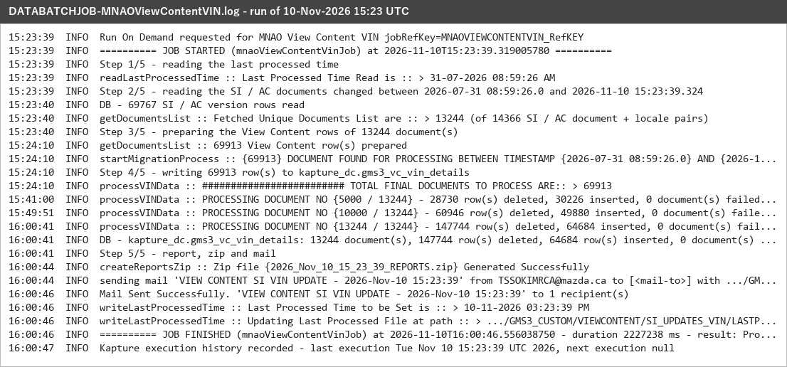
DATABATCHJOB-MNAOViewContentVIN.log - 10-Nov-2026 15:23 UTC
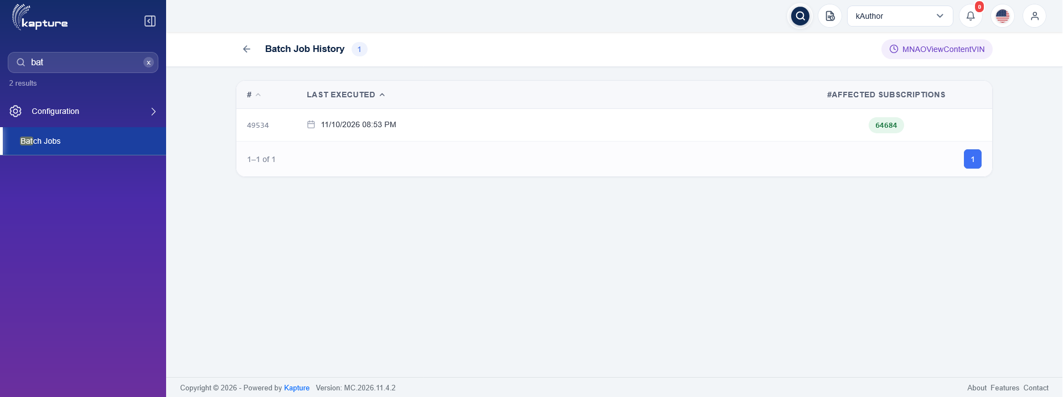
MNAOViewContentVIN - Batch Job History
Status: Pass
Remarks:

- System should write the incremental data report and the last processed time.
Steps:
1. Open GMS3_CUSTOM/VIEWCONTENT/SI_UPDATES_VIN.
Expected Result:
- <run time>/<run time>_REPORTS.zip holds INCREMENTAL_DATA_REPORT.xlsx (27 columns) with WMI, VDS and VIS ranges of each row.
- LASTPROCESSEDTIMESTAMP.txt = 10-11-2026 03:23:39 PM.
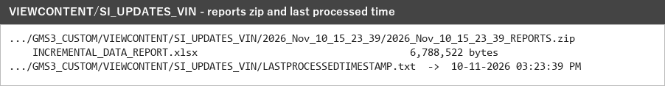
SI_UPDATES_VIN folder
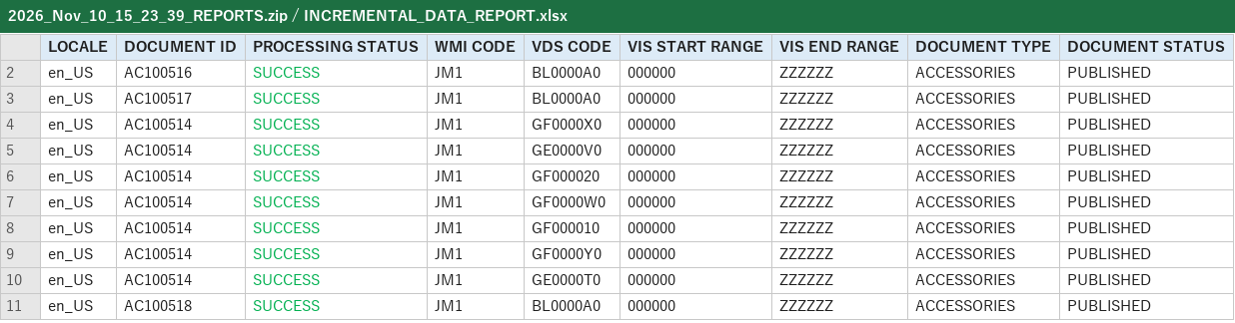
INCREMENTAL_DATA_REPORT.xlsx
Status: Pass
Remarks:

MC View Content (MCViewContent)
Keeps the MC (Japan) VIN View Content table (gms3_vc_japan_vin_details) up to date for the ja_JP SI documents changed since the last run.
- User should be able to view the schedule of the MCViewContent batch job.
Steps:
1. Open kAuthor and go to Configuration > Batch Jobs.
2. Click Update on MCViewContent.
Expected Result:
- Update batch job shows Job Name MCViewContent, its Job Reference Key and Job Actions MGSS Batch Job.
- Schedule Details: Recurring Every 1 hours; Retention Period 5 days.
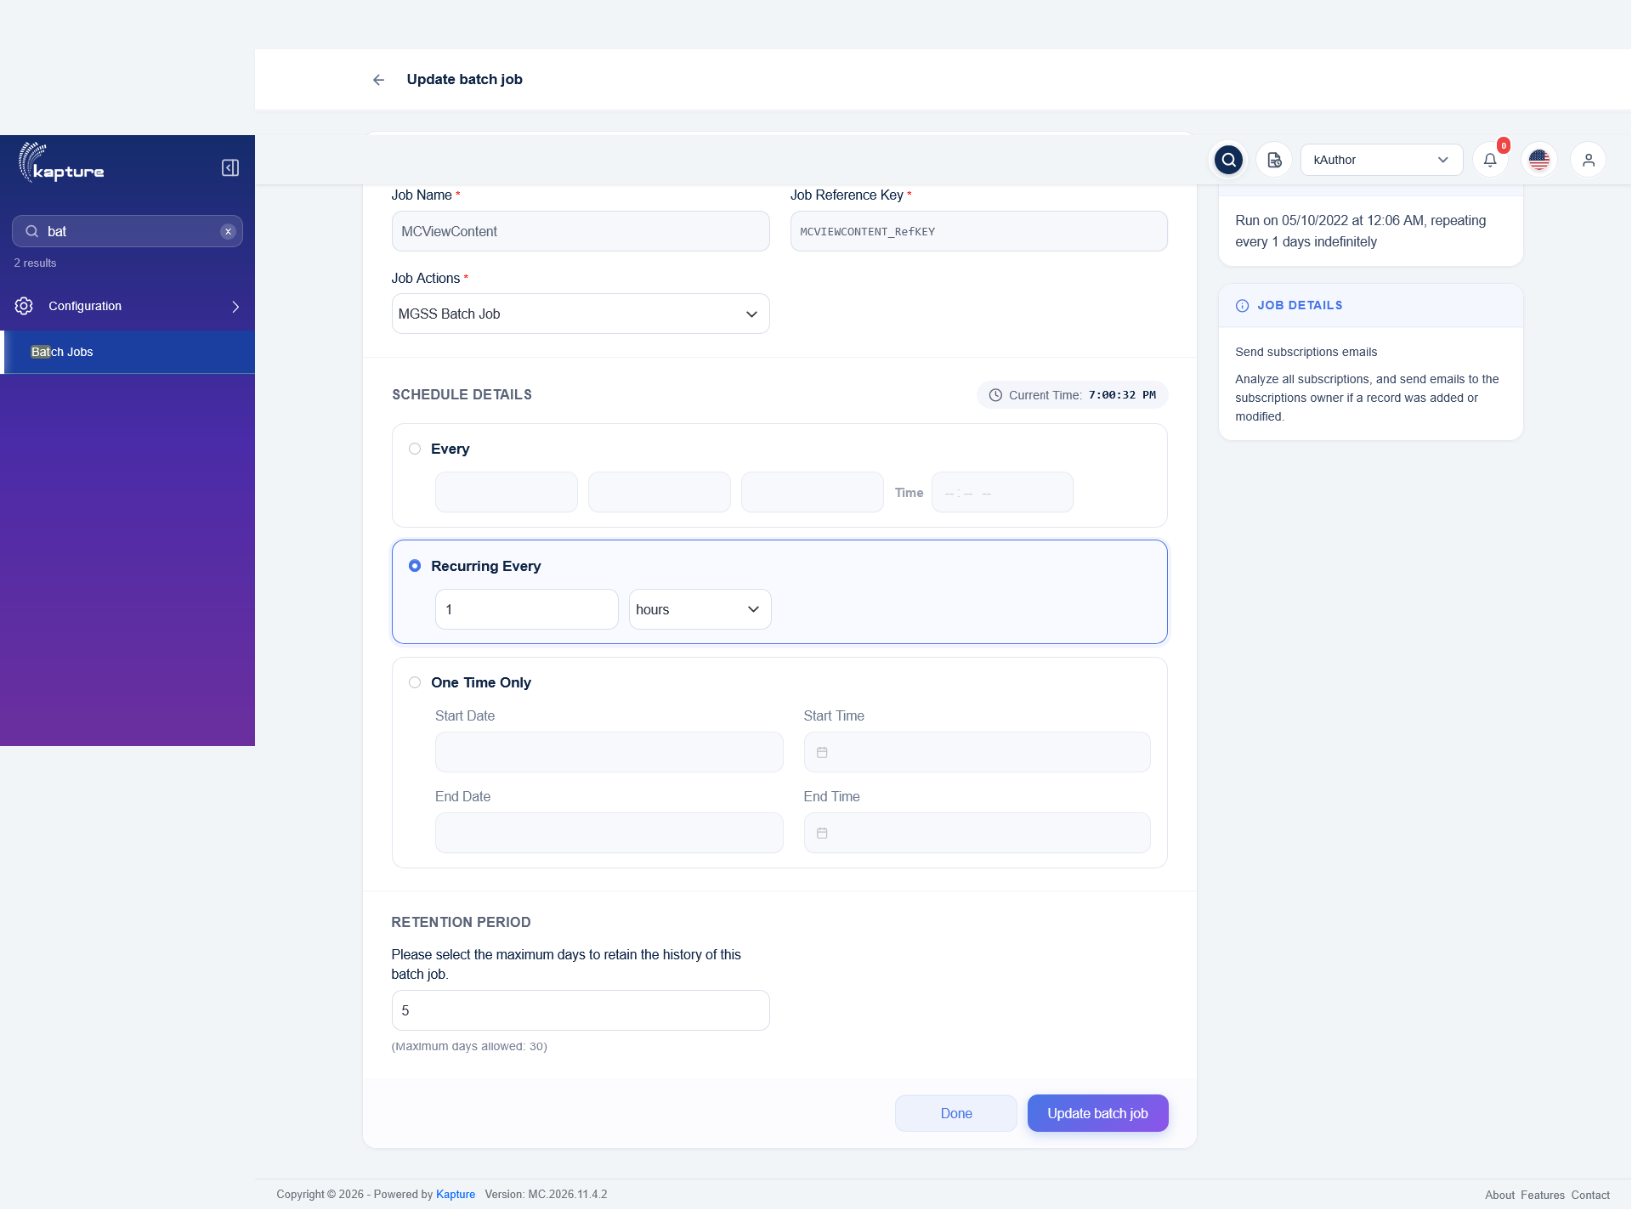
MCViewContent - Update batch job
Status: Pass
Remarks:

- System should rebuild the MC View Content rows of the changed documents.
Steps:
1. Run MCViewContent.
2. Check DATABATCHJOB-MCViewContent.log and History.
Expected Result:
- 5,374 ja_JP SI documents changed since the last processed time are read.
- 14,195 View Content rows prepared; 13,650 rows inserted, 0 documents rolled back.
- Report zipped, mail "VIEW CONTENT MC SI UPDATE - <time>" sent and the last processed time written.
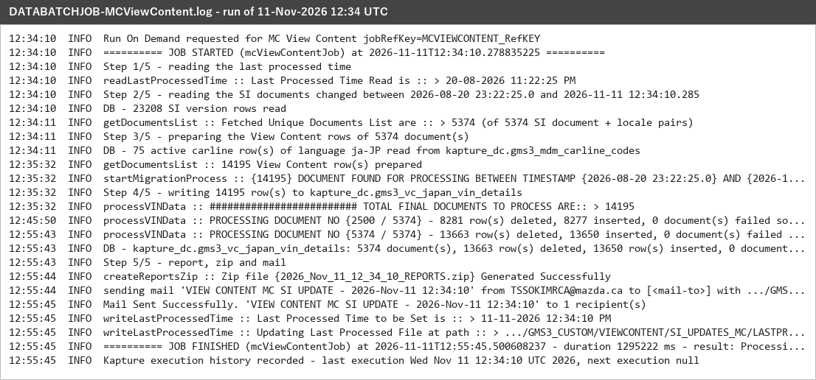
DATABATCHJOB-MCViewContent.log - 11-Nov-2026 12:34 UTC
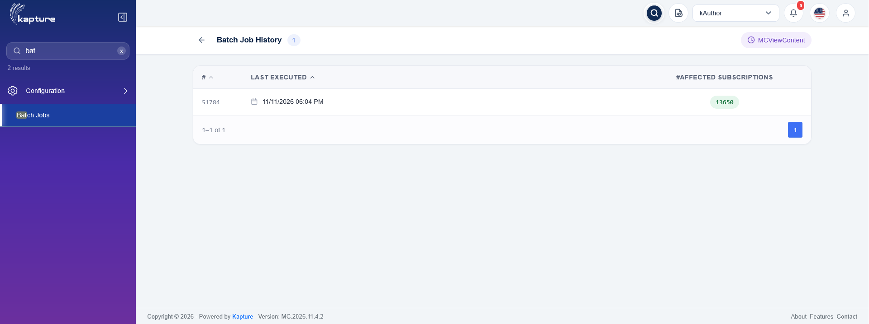
MCViewContent - Batch Job History
Status: Pass
Remarks:

- System should write the incremental data report and the last processed time.
Steps:
1. Open GMS3_CUSTOM/VIEWCONTENT/SI_UPDATES_MC.
Expected Result:
- <run time>/<run time>_REPORTS.zip holds INCREMENTAL_DATA_REPORT.xlsx (44 columns), all rows SUCCESS.
- LASTPROCESSEDTIMESTAMP.txt = 11-11-2026 12:34:10 PM.
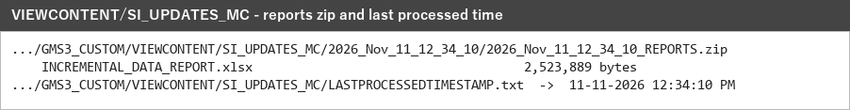
SI_UPDATES_MC folder
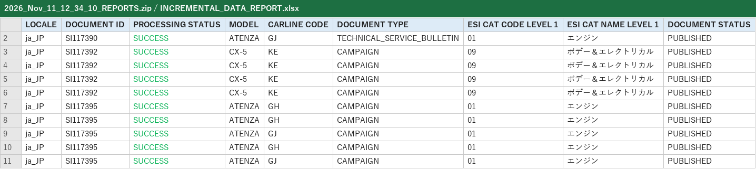
INCREMENTAL_DATA_REPORT.xlsx
Status: Pass
Remarks:

MME View Content (MMEViewContent)
Keeps the MME VIN View Content table (gms3_vc_mme_vin_si_detail) up to date for the SI and Video documents of the 39 MME locales changed since the last run.
- User should be able to view the schedule of the MMEViewContent batch job.
Steps:
1. Open kAuthor and go to Configuration > Batch Jobs.
2. Click Update on MMEViewContent.
Expected Result:
- Update batch job shows Job Name MMEViewContent, its Job Reference Key and Job Actions MGSS Batch Job.
- Schedule Details: Recurring Every 1 hours; Retention Period 5 days.
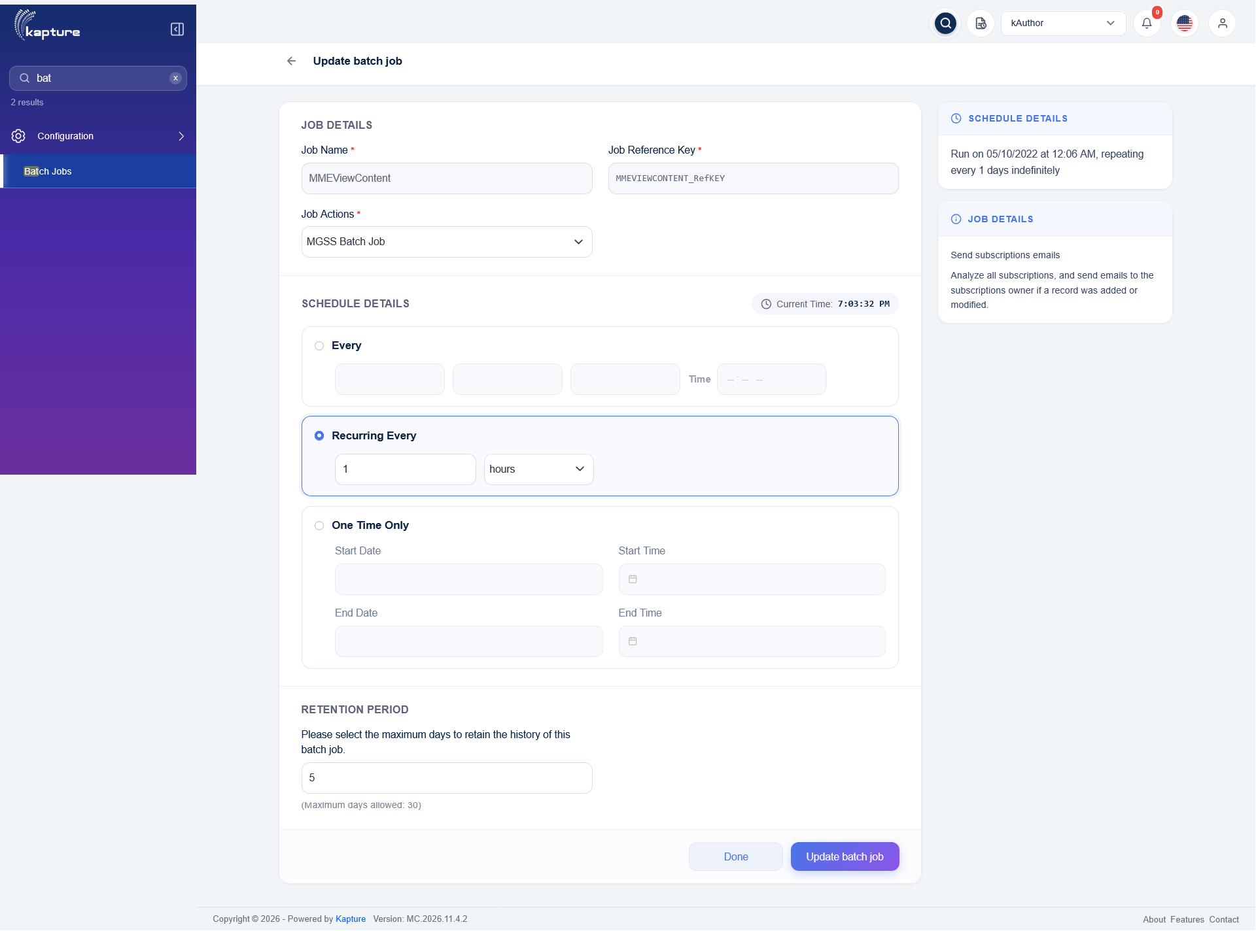
MMEViewContent - Update batch job
Status: Pass
Remarks:

- System should rebuild the MME View Content rows of the changed documents.
Steps:
1. Run MMEViewContent.
2. Check DATABATCHJOB-MMEViewContent.log and History.
Expected Result:
- 3,036 SI / Video document + locale pairs changed since the last processed time are read.
- 33,980 View Content rows prepared; each document's rows are replaced in one transaction (32,100 rows inserted).
- Report zipped and mail "VIEW CONTENT MME UPDATE - <time>" sent.
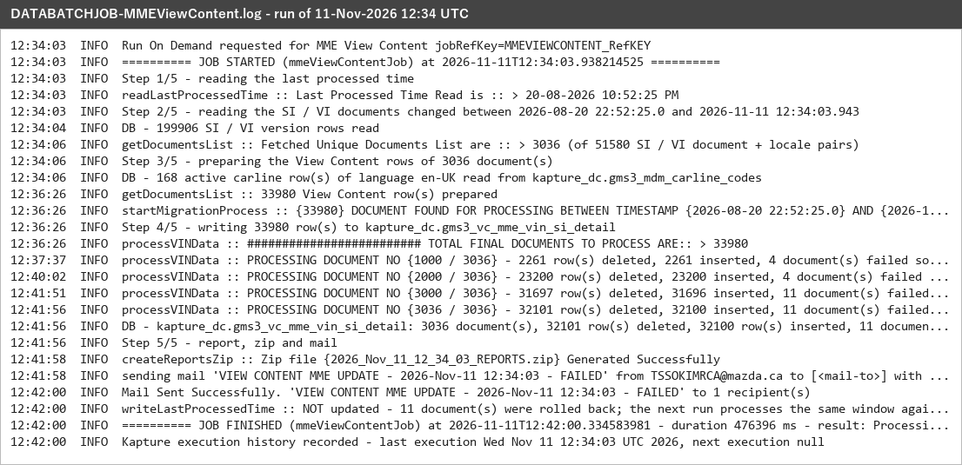
DATABATCHJOB-MMEViewContent.log - 11-Nov-2026 12:34 UTC
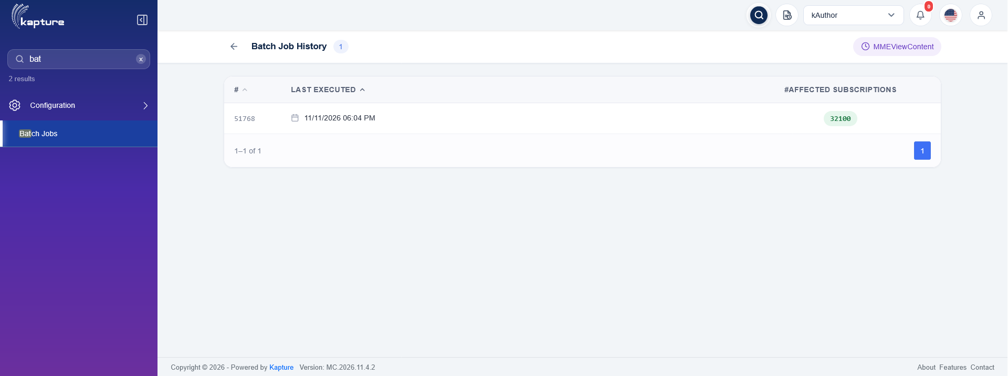
MMEViewContent - Batch Job History
Status: Pass
Remarks: 11 test documents carry ESI categories whose reference keys were created wrongly (longer than the ESI code column); they are rolled back and reported FAILURE, the mail is marked FAILED and the last processed time is kept so the window is processed again. Data issue, accepted.

- System should write the incremental data report.
Steps:
1. Open GMS3_CUSTOM/VIEWCONTENT/MME_VC_UPDATES.
Expected Result: <run time>/<run time>_REPORTS.zip holds INCREMENTAL_DATA_REPORT.xlsx (36 columns) with carline, model, document type, ESI categories (MDM names) and status of each row.
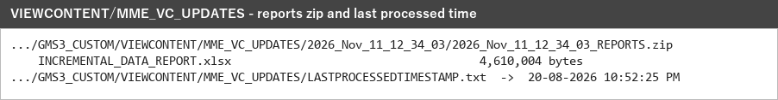
MME_VC_UPDATES folder
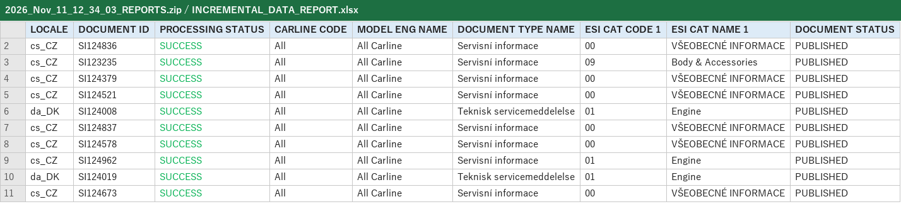
INCREMENTAL_DATA_REPORT.xlsx
Status: Pass
Remarks:

